# Webhooks Assignment

- Installed and started httpd on JM
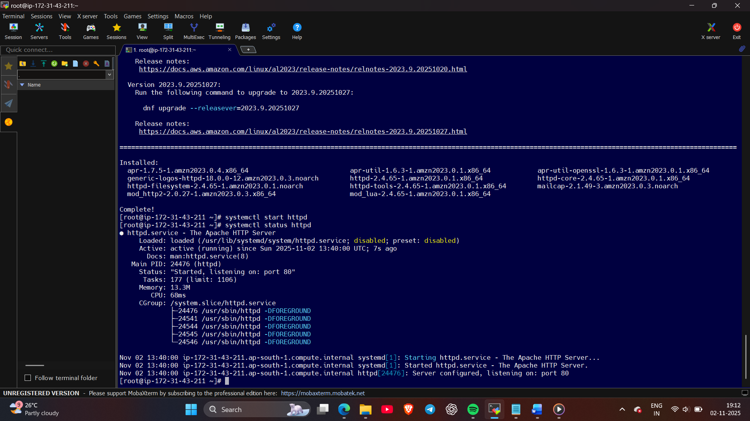
- Created API connection between Jenkins and Github
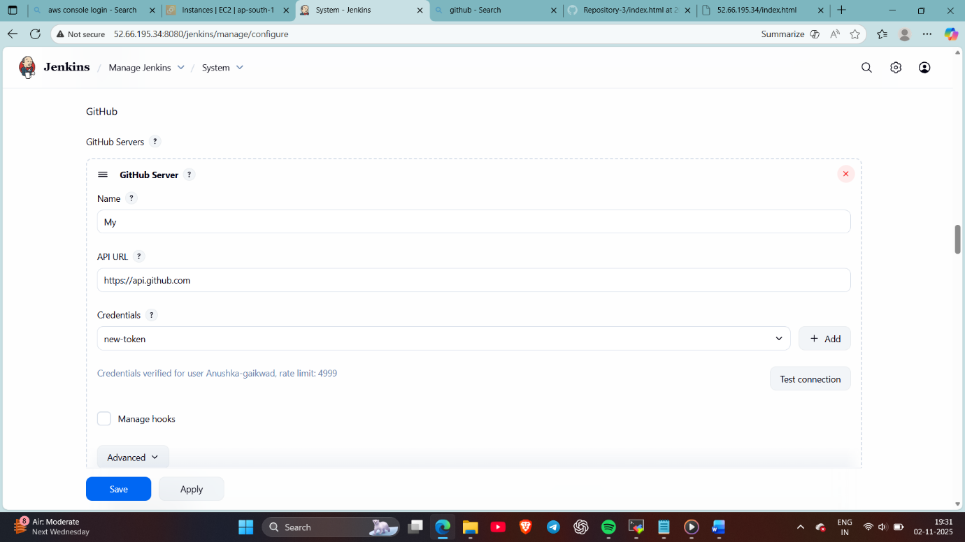
- Created 3 repositories : in Repo 1 created 2025Q1 branch and in that created index.html file.
In repo 2 created 2025Q2 branch and in that created index.html file.
In repo 3 created 2025Q3 branch and in that created index.html file.
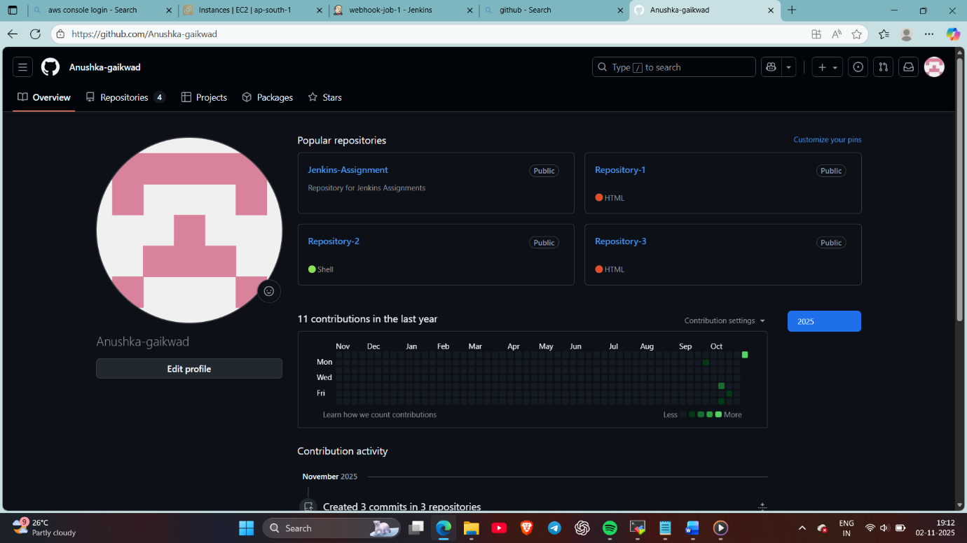
- Created 3 jobs :
Job 1 : added repo 1 link and mentioned branch, selected github hook trigger for Gitscm polling
And copied index.html file in execute shell
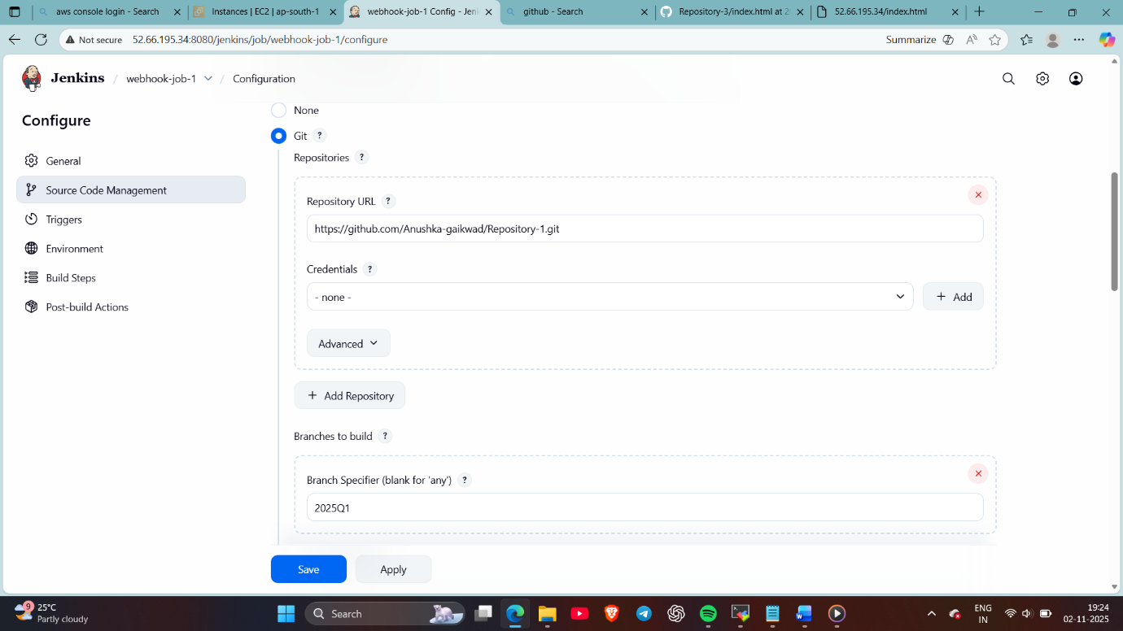
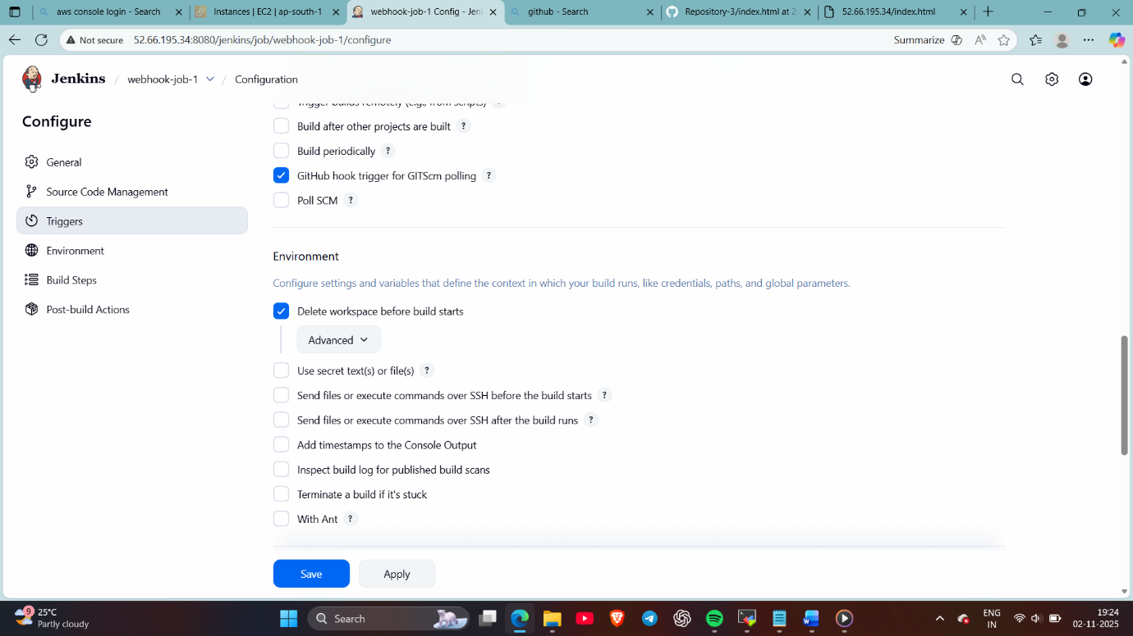
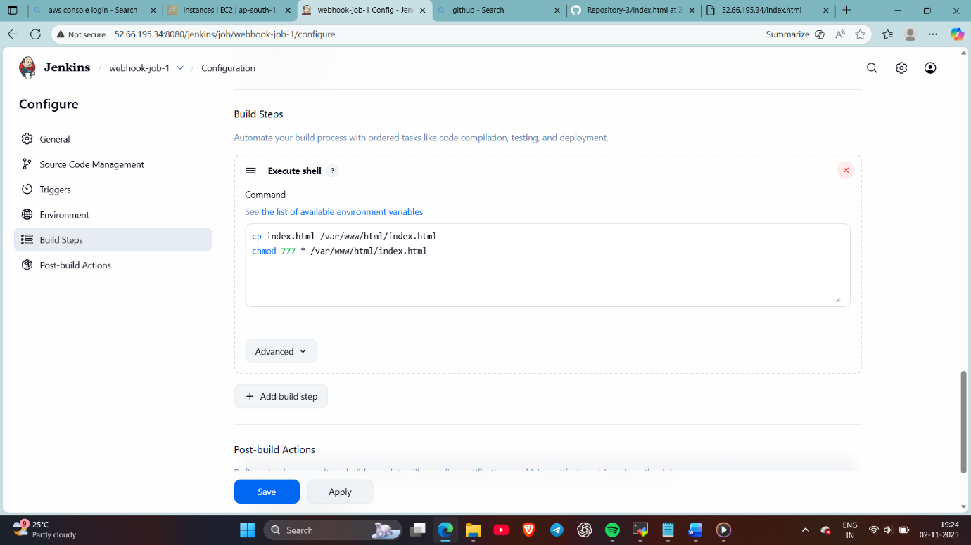
- Like this created job 2 and 3 but mentioned repo 2 in job 2 and repo 3 in job 3
- Done webhook setting in Github in each repository
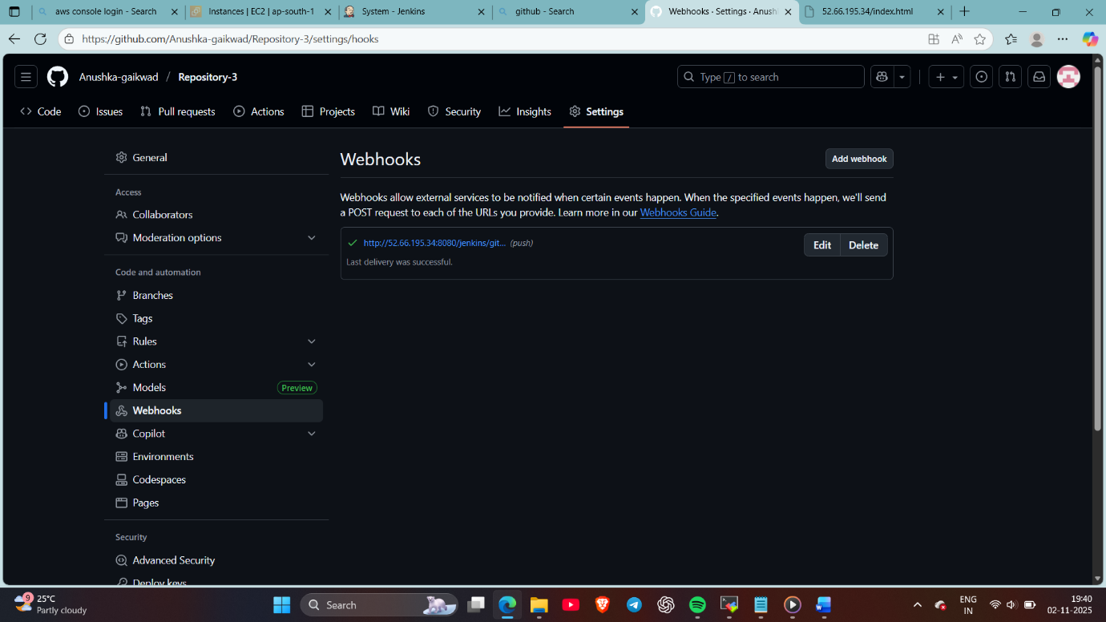
- Now whenever I’ll edit the file or anything on the Github automatically job will be build
Here I have done changes in the repo 1’s index file and automatically job is build
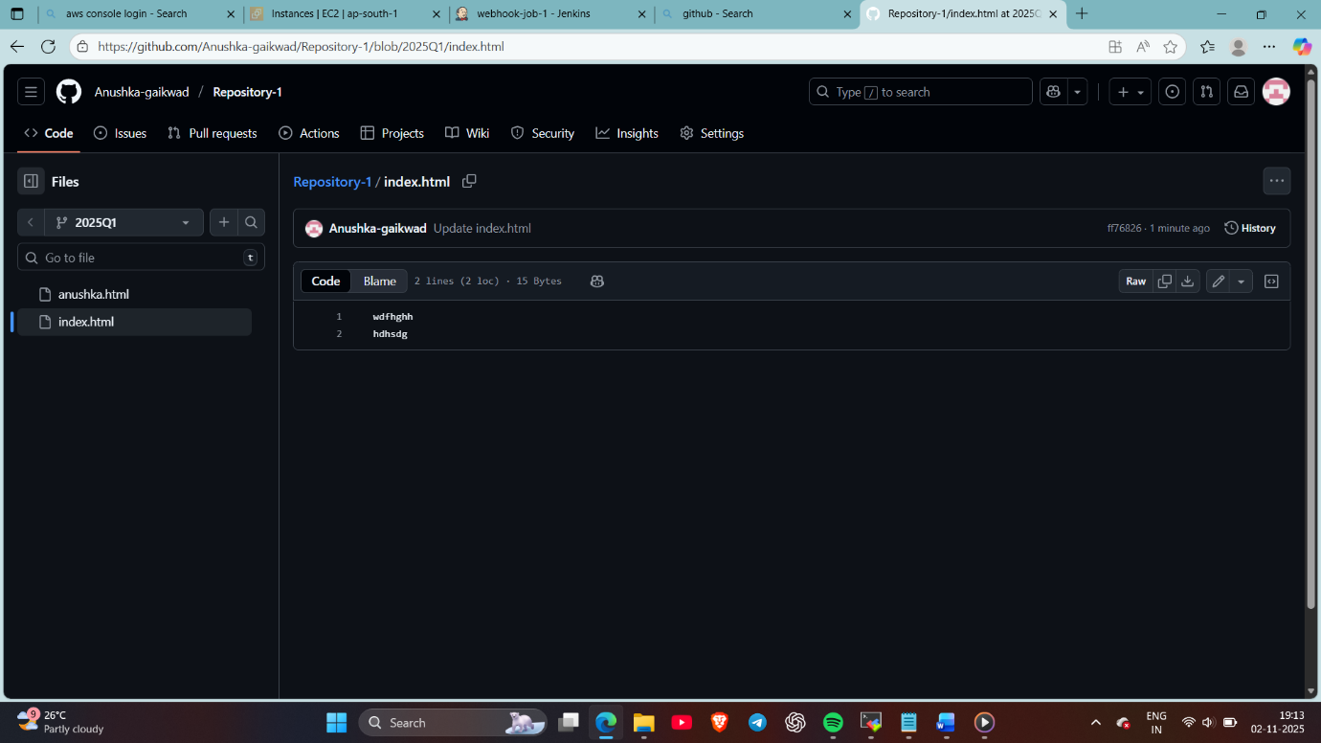
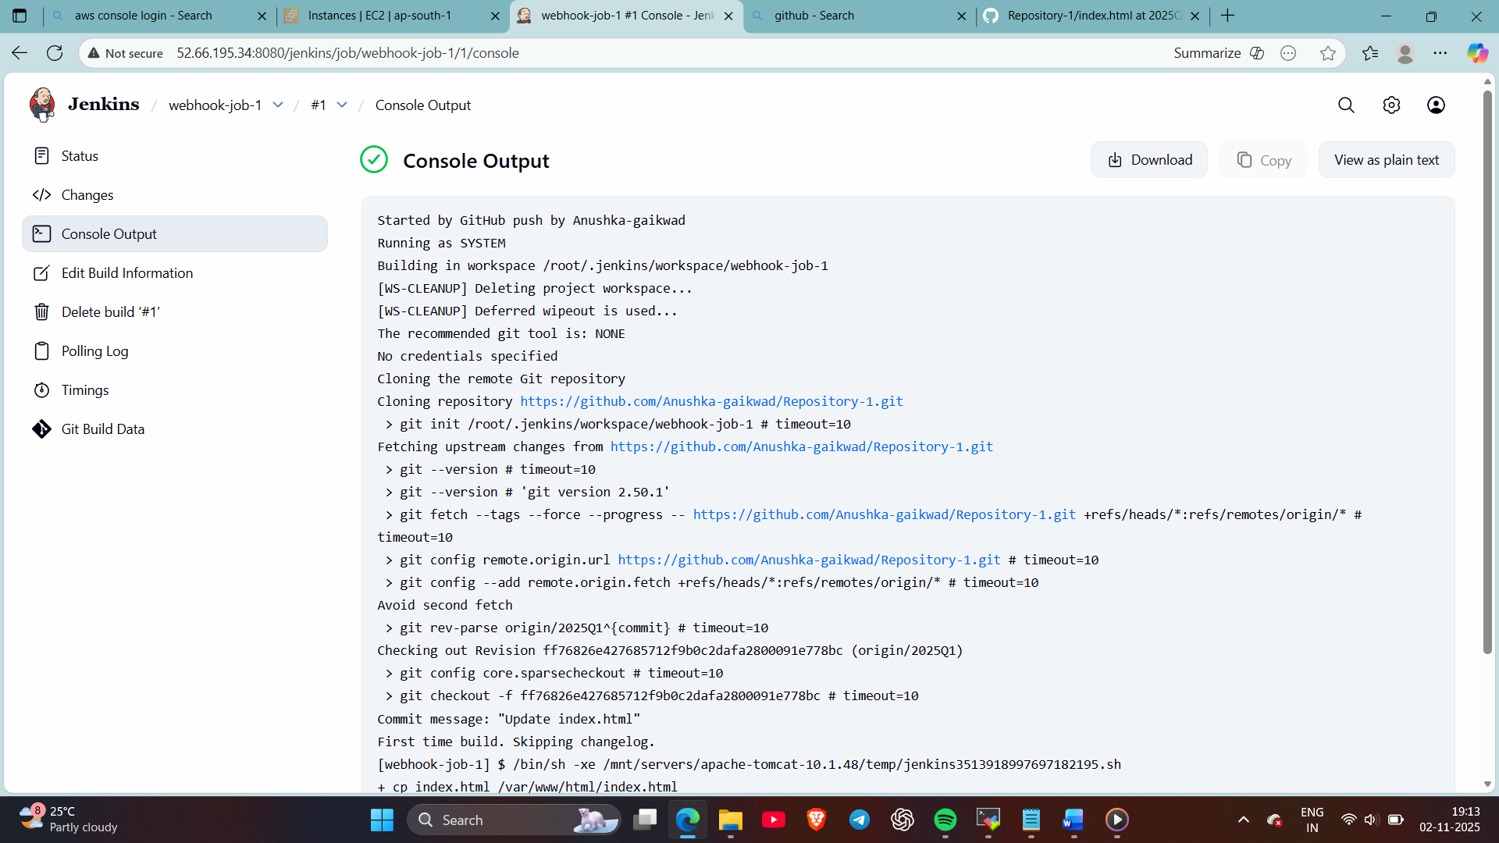
Also checked the deployment of index.file over httpd
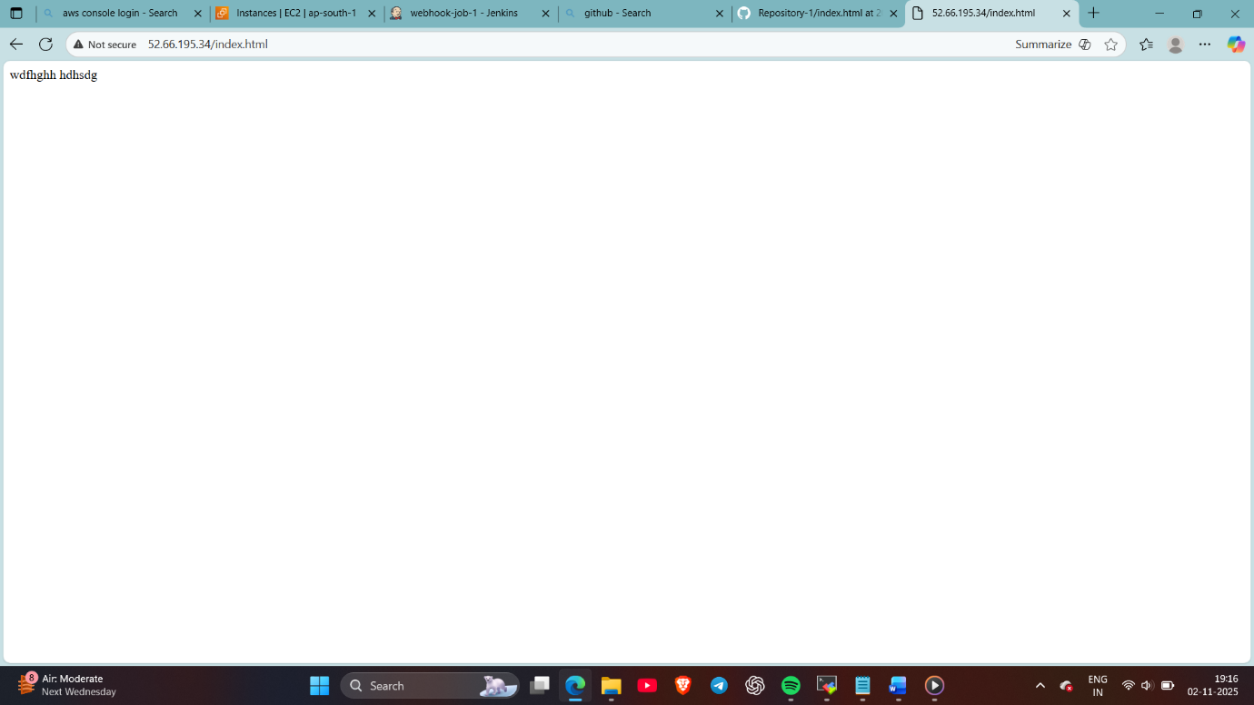
- Now same done in repo 2 and job is build and also checked the index deployment on apache httpd (old repo 1’s file is deleted because ive selected delete workspace before new build starts in job)
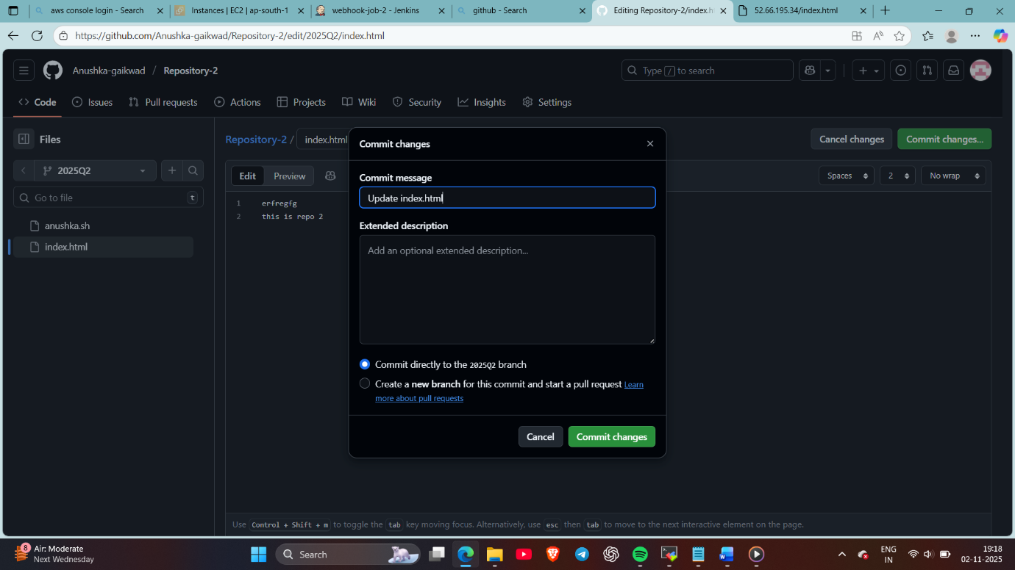
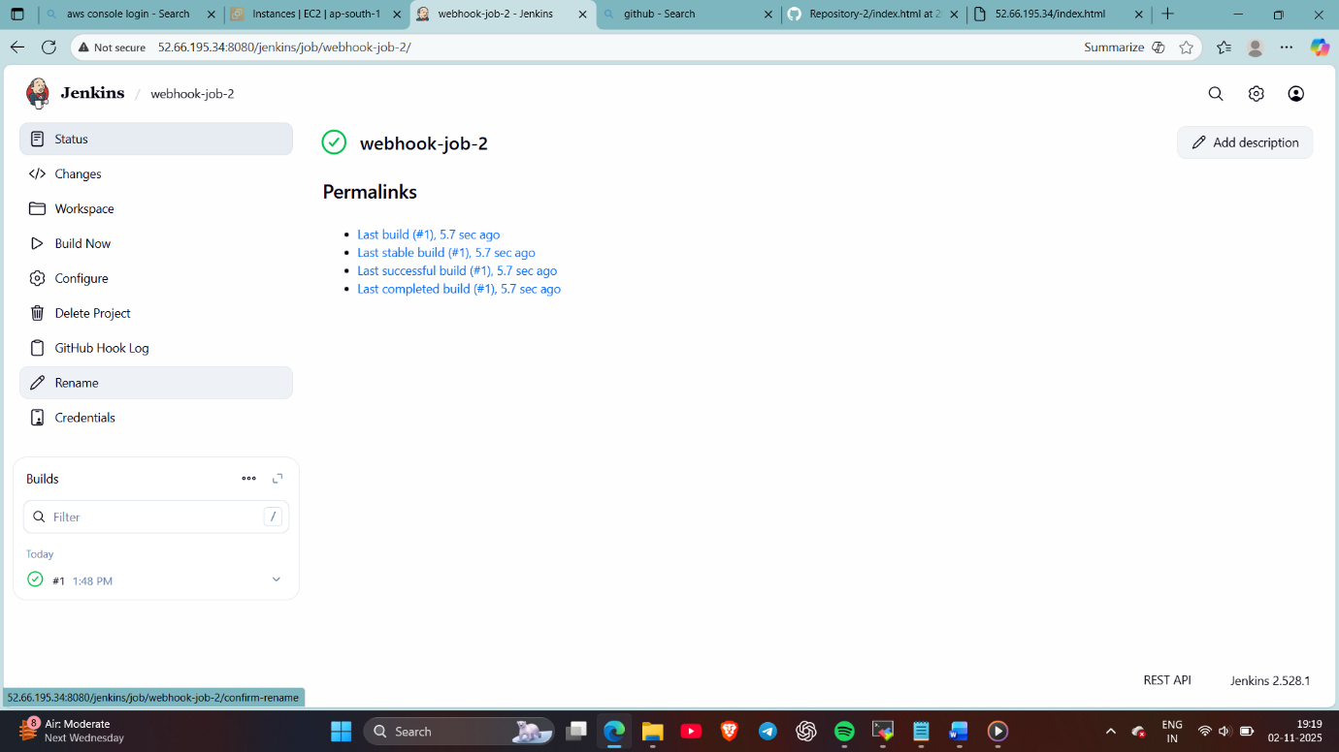
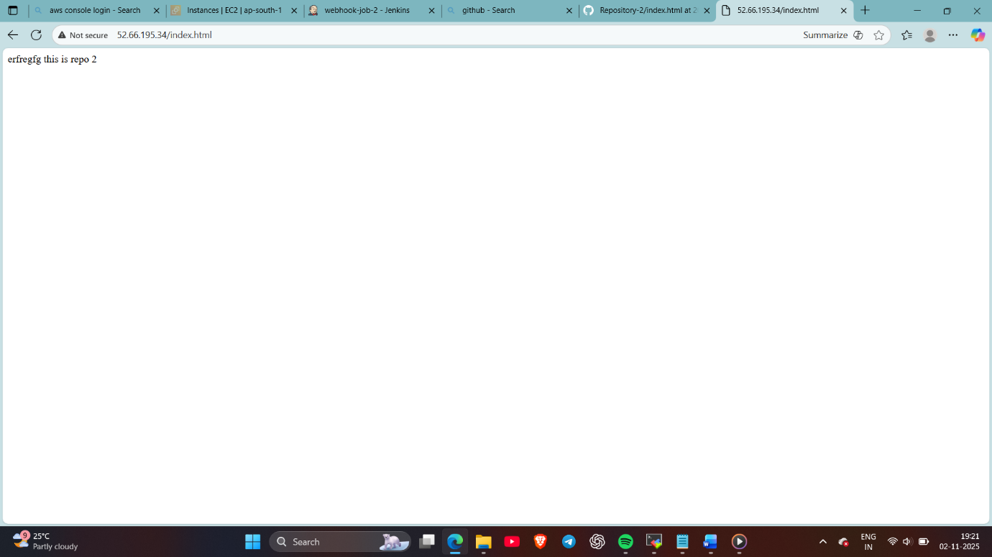
Also same is done in repo 3
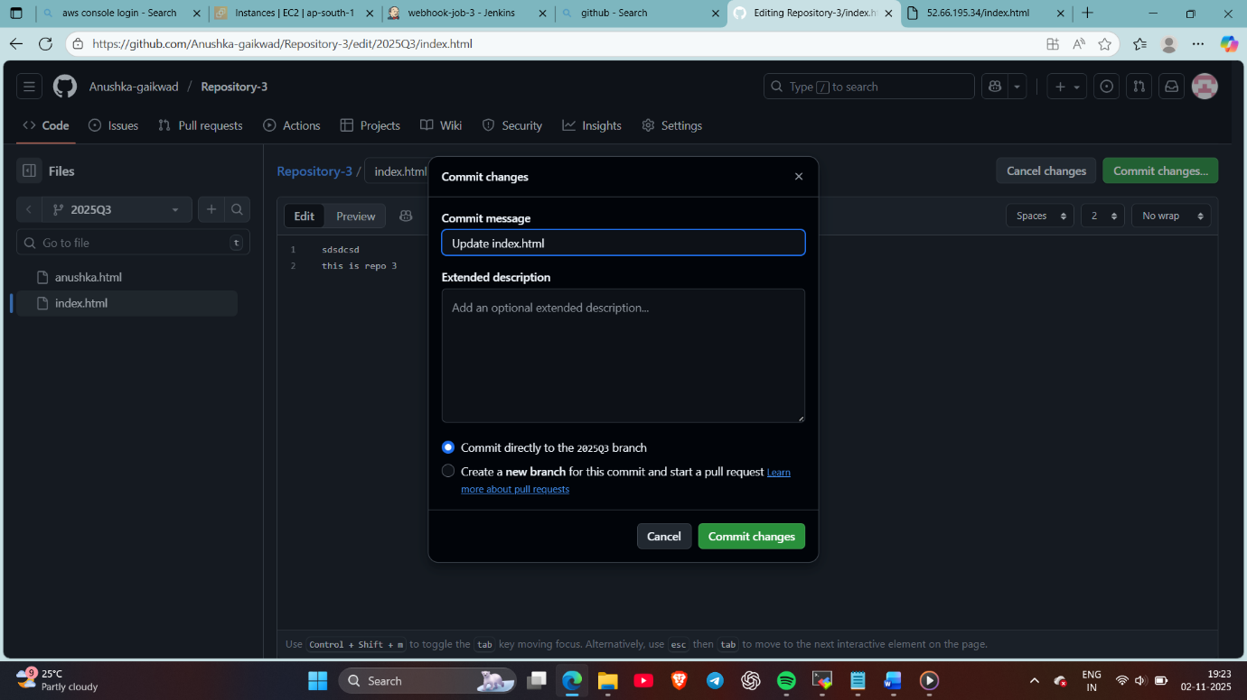
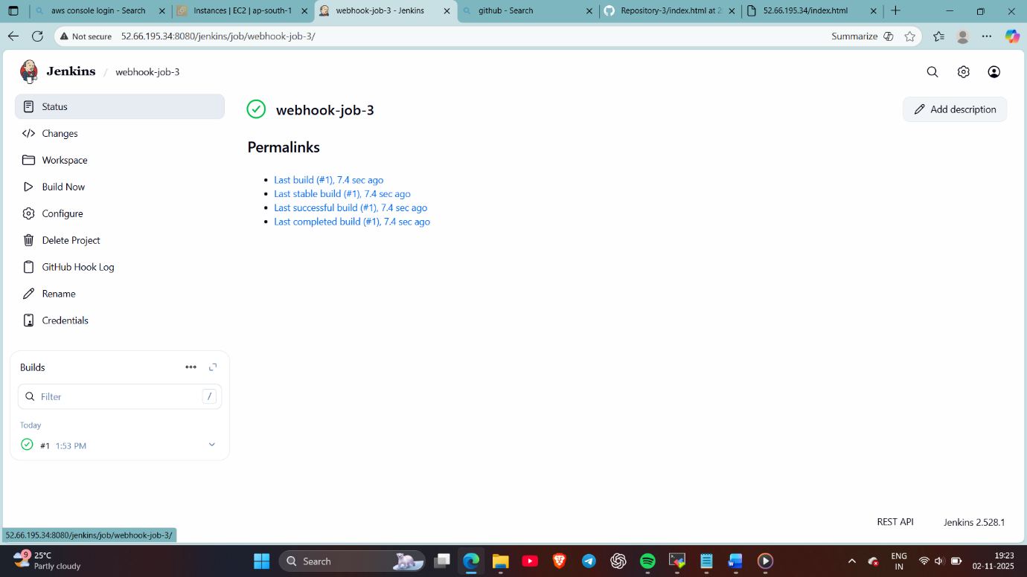
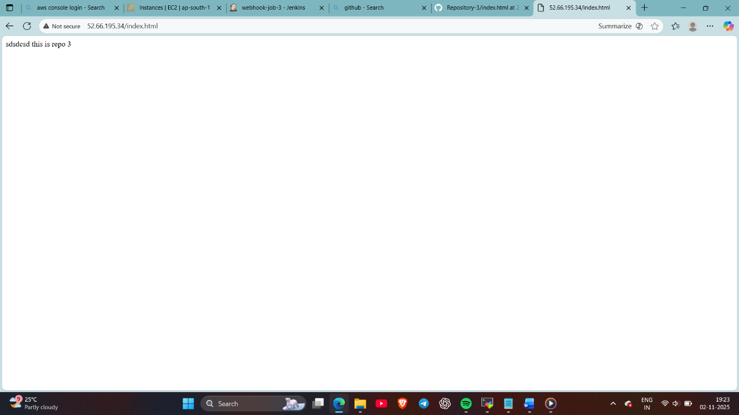

Thank you

